**Problem 1**

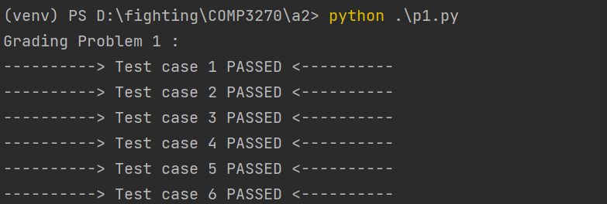

A good start, it means out program is on the right way, we have the basic configuration to finish the left journey.

**Problem 2**

We can have the following runtime shortcuts to have the following table of the executing time consumption.

|  |  |  |  |
| --- | --- | --- | --- |
| **Problem index** | **Win rate(%)** | **Execution time(m)** | **Parameters** |
| **Q1** | **100** | **0.5256** | **1 100 0** |
| **Q2** | **100** | **0.0100** | **2 100 0** |
| **Q3** | **100** | **0.1352** | **3 100 0** |
| **Q4** | **90** | **4.6363** | **4 100 0** |
| **Q5** | **100** | **934.1662** | **5 10 0** |

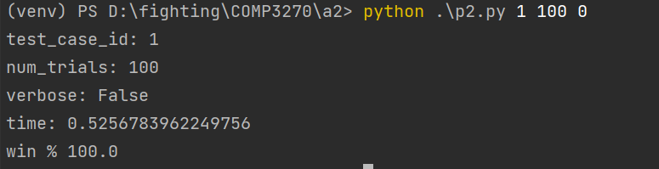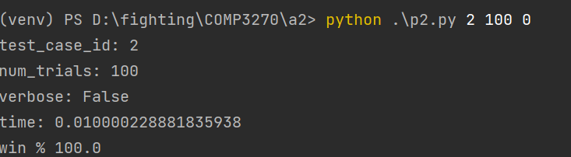

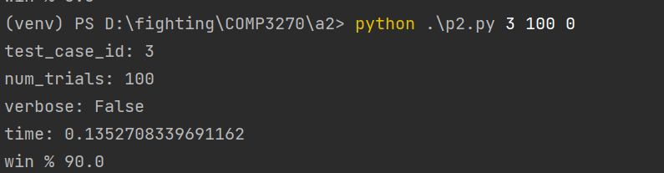

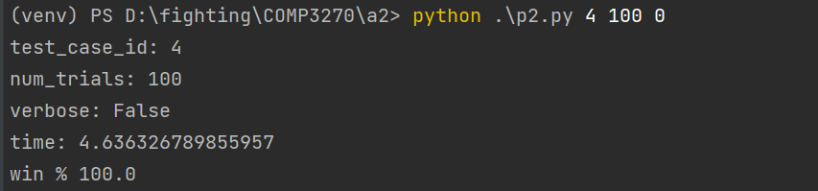

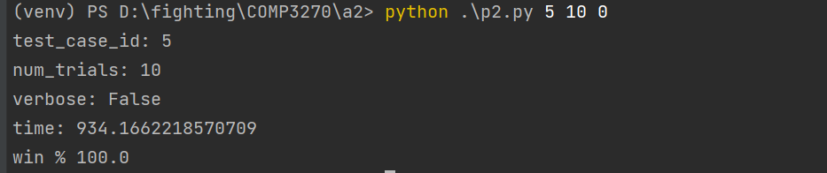

**Problem 3**

Now, we take multiple ghosts case into consideration, first of all, make the working formally.

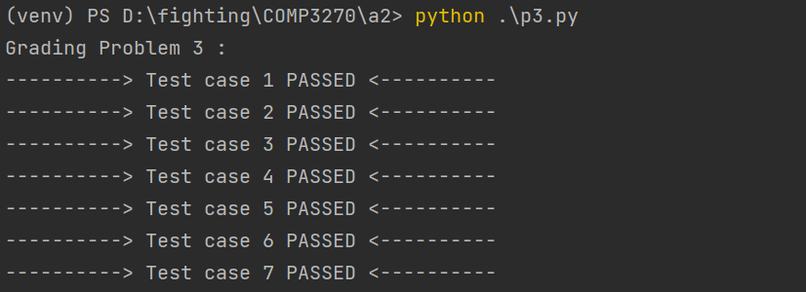

**Problem 4**

We can have the following runtime shortcuts to have the following table of the executing time consumption.

|  |  |  |  |
| --- | --- | --- | --- |
| **Problem index** | **Win rate(%)** | **Execution time(m)** | **Parameters** |
| **Q1** | **38** | **0.343** | **1 100 0** |
| **Q2** | **75** | **0.007** | **2 100 0** |
| **Q3** | **28** | **0.024** | **3 100 0** |
| **Q4** | **72** | **14.014** | **4 100 0** |
| **Q5** | **34** | **0.050** | **5 100 0** |
| **Q6** | **37** | **0.128** | **6 100 0** |
| **Q7** | **31** | **0.124** | **7 100 0** |
| **Q8** | **60** | **434.596** | **8 50 0** |
| **Q9** | **30** | **259.334** | **9 50 0** |

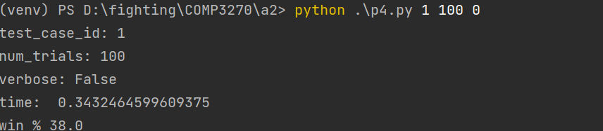

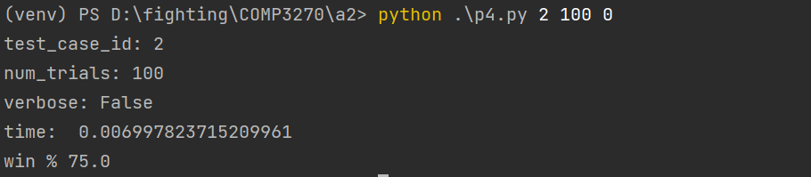

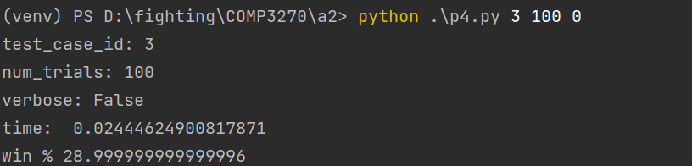

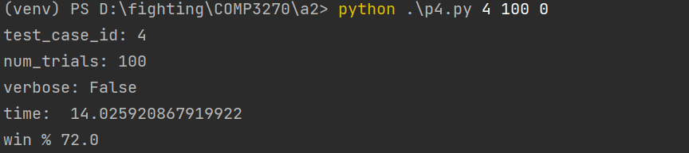

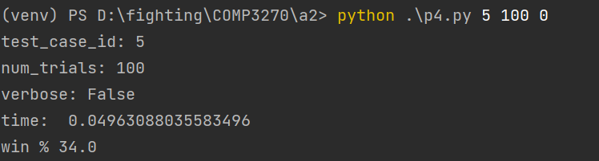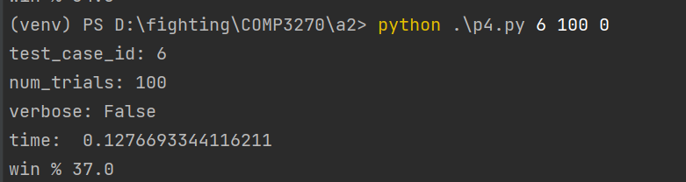

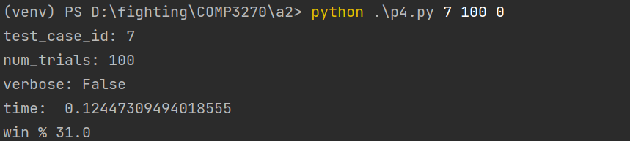

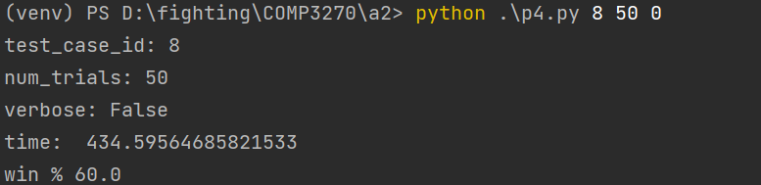

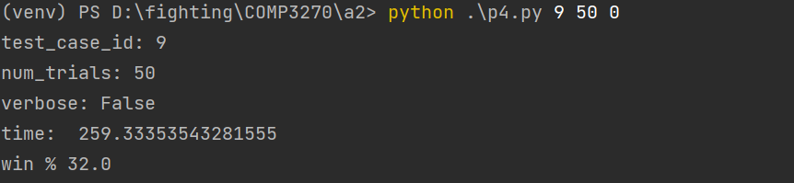

**Problem 5**

Due to the page limits, we only show the table for the left.

|  |  |  |  |
| --- | --- | --- | --- |
| **Problem index** | **Win rate(%)** | **Execution time(m)** | **Parameters** |
| **Q1** | **100** | **0.101** | **1 3 100 0** |
| **Q2** | **100** | **1.036** | **2 3 100 0** |
| **Q3** | **89** | **0.164** | **3 3 100 0** |
| **Q4** | **77** | **0.243** | **4 3 100 0** |
| **Q5** | **89** | **7.437** | **5 3 100 0** |
| **Q6** | **100** | **3.257** | **6 3 100 0** |
| **Q7** | **100** | **30.258** | **7 3 100 0** |
| **Q8** | **85** | **782.596** | **8 3 100 0** |

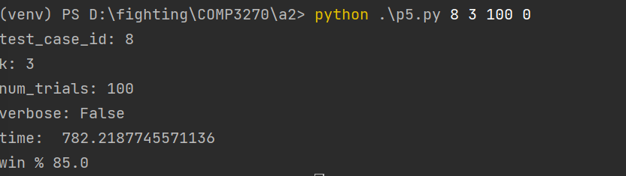

**Problem 6**

|  |  |  |  |
| --- | --- | --- | --- |
| **Problem index** | **Win rate(%)** | **Execution time(m)** | **Parameters** |
| **Q1** | **38** | **0.543** | **1 3 100 0** |
| **Q2** | **77** | **0.004** | **2 3 100 0** |
| **Q3** | **34** | **0.134** | **3 3 100 0** |
| **Q4** | **68** | **12.014** | **4 3 100 0** |
| **Q5** | **37** | **0.450** | **5 3 100 0** |
| **Q6** | **41** | **0.297** | **6 3 100 0** |
| **Q7** | **38** | **0.224** | **7 3 100 0** |
| **Q8** | **72** | **645.597** | **8 3 50 0** |
| **Q9** | **34** | **499.314** | **9 3 50 0** |

**Each task taking time(include debug time)**

|  |  |
| --- | --- |
| **Problem index** | **Time taken(h)** |
| **P1** | **6** |
| **P2** | **3** |
| **P3** | **4** |
| **P4** | **5** |
| **P5** | **2.5** |
| **P6** | **2.5** |